What shall I bring for lunch?

Why is my child always dirty?

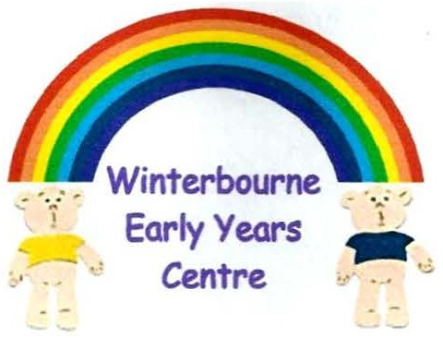

Can my child bring their toy in?

What do I bring for forest school?

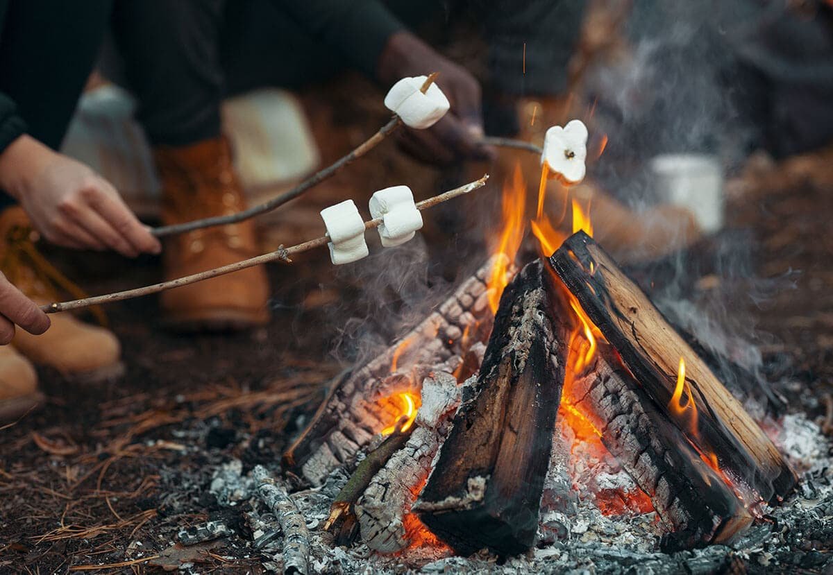
Hot weather KIT:
- Long sleeve top
- Long leg trousers
- Wellington boots
- Socks: Cover ankle
- Sun hat
- Light weight puddle suit
- Sun Cream (already applied at home)

We must cover our skin due to tics and being close to fire. Theres also plants and insects so need to protect ourselves from stings and scratches

We do carry out Forest School in areas with Nut trees, please talk to us regarding allergies.

We can be outside for long periods of time so without the correct kit then we may miss out on forest school.

Please remember to label everything and put in snack/drink trays
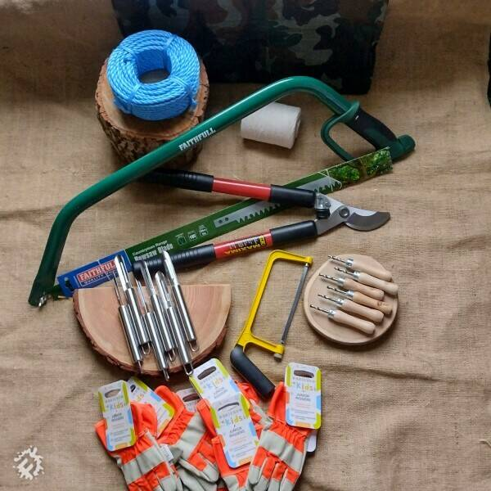
Forest School

Cold weather KIT:
- Long/thick sleeve top
- Long/thick trousers
- Fleece jumper
- Wellington/weatherproof boots
- Fluffy/thick socks
- Winter hat
- Thick/warm puddle suit
- We don’t wear scarfs due to risk of being pulled or dangling by flames

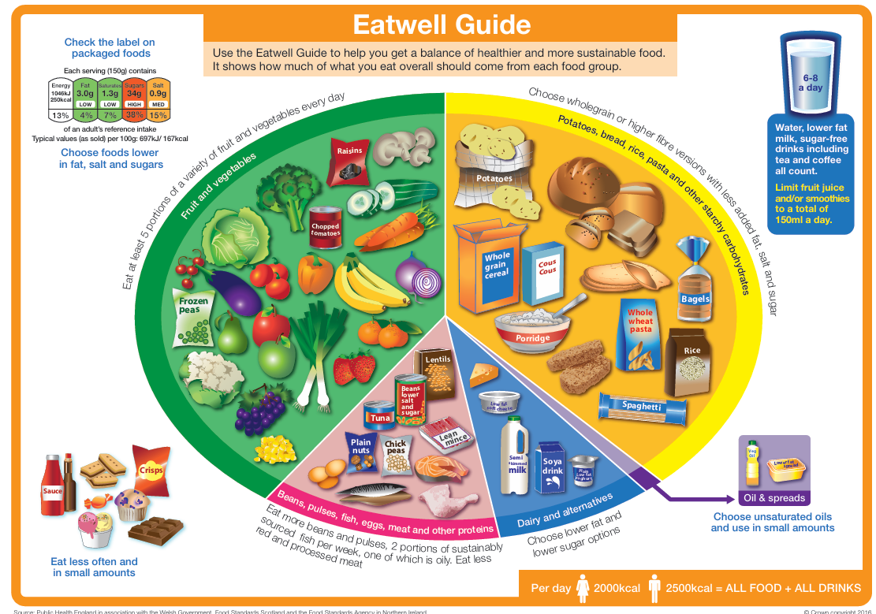

Lunchboxes
Recipe ideas can be found at: www.nhs.uk/healthier-families/recipes/healthier-lunchboxes/
Pop an ice pack inside to keep lunch fresh for longer.
1 treat ONLY please, multiple treats (choc, cakes and sugary snacks) will be sent home.



Morning snack:
- Children can eat when they feel hungry
- We provide the milk and water
- Please provide a piece of fruit and/or another healthy alternative.
- Please label your item clearly and pop in the snack box.
- Water bottle, water or squash

We’re a packet free snack setting, please don’t provide wrappers especially as these CANNOT be taken out to forest school.


Write name directly onto the banana skin

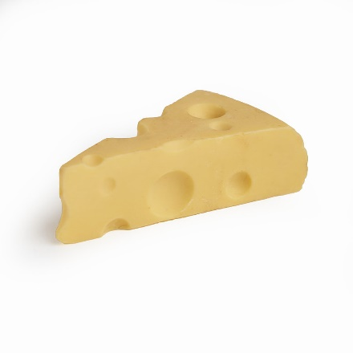
Don’t forget to label everything! From drinks bottle to snack, lunchbox to pots inside.

Snacks

Ideas:
- Piece of fruit
- Houmous or soft cheese and veg sticks
- Vegetables: carrots or peas go down well as they’re sweet
- Buttered crackers
- Rice cake
- Fruit muffins, malt loaf slice

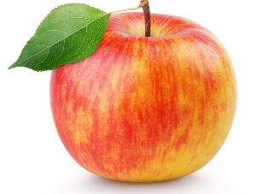

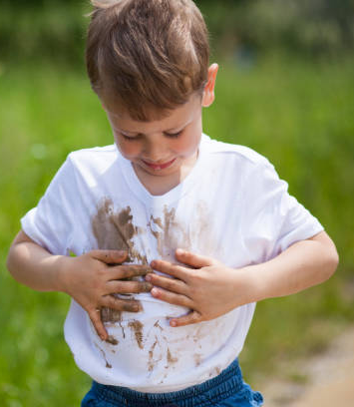
We do enjoy water play

I sometimes spill my milk

We have paint out every day

I like to lean on my felt tip pen!

We have lots of mud and sand
Spare clothes

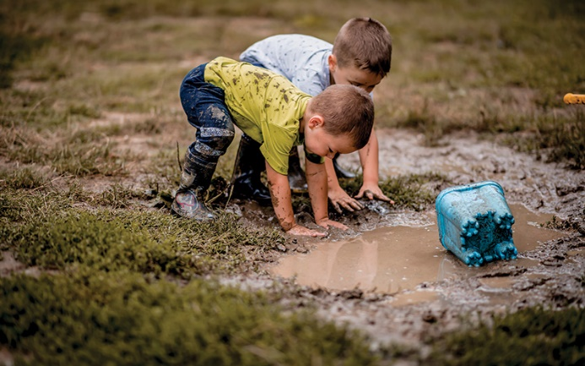

MY BAG
- AT LEAST two sets of spare clothes, including pants and socks.
- If your child is toilet training….. provide more ESPECIALLY extra pants and socks.
- Check your bag is weather appropriate.
- Wet wipes and nappies for those who require them

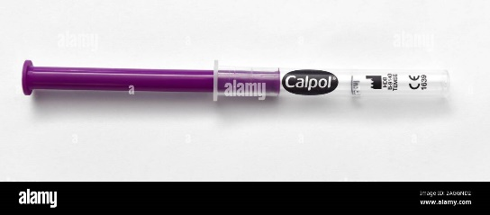
MEDICINE
We ONLY allow medicines onsite that have a prescription. We will not be able to administer any over the counter medication.

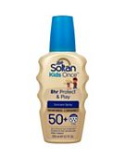
SUNCREAM
We do not apply suncream to children during hot weather, we expect children to arrive pre creamed using an 8hr suncream, they’re only with us for 6hrs! Don’t worry we provide plenty of shaded play.
Good to know

ITEMS FROM HOME
We have plenty here on offer, please don’t bring things in from home, there’s really no need to! If children do bring things in, they often end up lost or broken as peers like to explore them too.
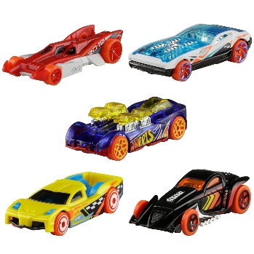

MISSING ITEMS
We have on average 100-120 children across the centre! That’s a lot of stuff that can go missing, Remember to Label, Label, Label and things always show up eventually.

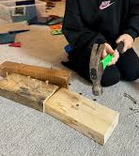

IN THE MOMENT LEARNING
We let children be children, we like independence and encourage own choices. We allow risky play and ensure that we risk assess what is offered.

